In this lesson we area going to be animating a logo onto the screen and animating it off and having some text appear on the screen there will be a background involve basically we are using all the skills that we have learned so far in our natron tutorial series so if you are still unsure then you can revise your lesson
We will not learn something new we will just see what we have seen so far and create a project from our acquired skills So it willl be a very good practise for us

So in our project setting you see

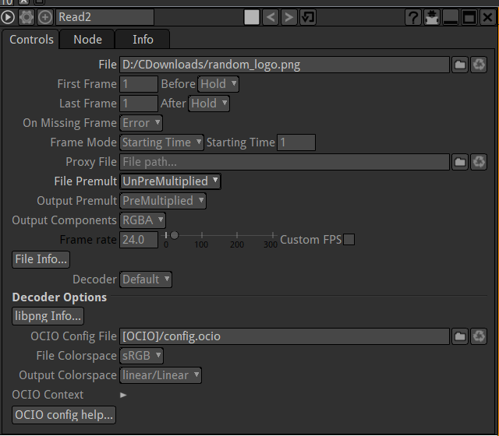

we can see above that there are total 250 frames and the frame rate is 24
So now doing some basic methods we can figure if its 24 frames every second
After 10 second it means 24 times 10 then it will be 240 feames it is pretty close to 250
So our project will be 10 second if we leave things exactly the same here
It will be good if your image size is equal to the project size(this is default 1920 X 1080)
but if not then create your format manually and use it that fits the size of image

So we import our bg image and then link it to viewer and then also import icon image and also link it to viewer node as shown below

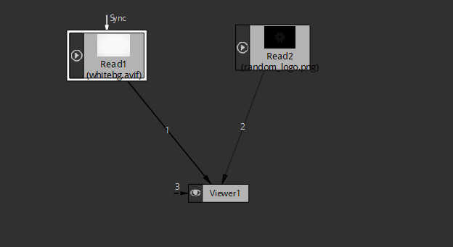
You can toggle between both the read node in viewer window by pressing 1 and 2
or any number associated to the path between viewer and read nodes

2:00
So now we will do merge with the images with the help of merge node and set the the white background as bg(link b line from viewer to white bg read node) and logo image as front image (logo to A line of Viewer) as shown below

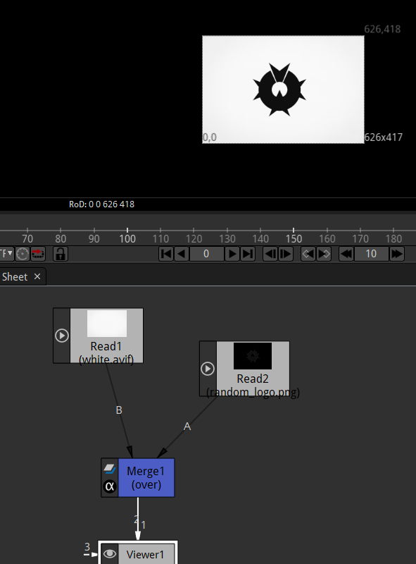
Now we cannot move around the logo in our viewer and animate the movement. To do that we need to add additional functionality that is transform to our logo read node(in line form logo image to viewer node)
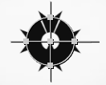
Now there is controls for the image in the viewer window to move it around and scale it and rotate it

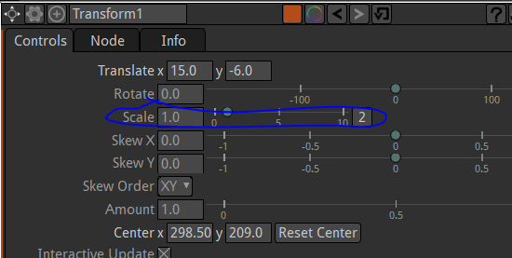
To increase the size of the node to which transform is attached you can increase the size property in the Transform properties as shown above

Now to animate below

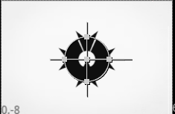
We are not gonna worry about text yet
What i want that logo should start from left side of the screen and then we want to slide in and slide out

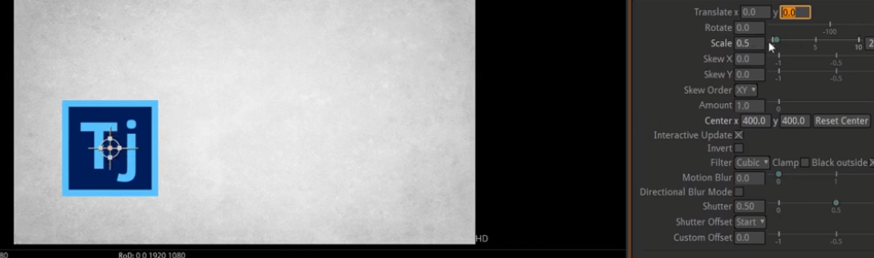
Now when you make the transform x and transform y 0 then it will be like above it is not touching the bottom left screen becasue scale is 0.5 if we set scale to 1 then it will be like below touching the bottom of the screen

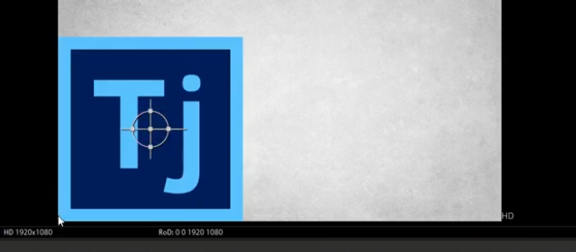
I think the scaling happens from top right corner (maybe(Teacher don't know how it worked))
So it tell us that we take reference when piosition to the bottom left of teh screen
WE drag the logo to extreme left out of the screen as sheon below
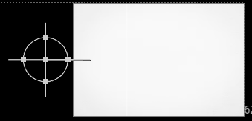
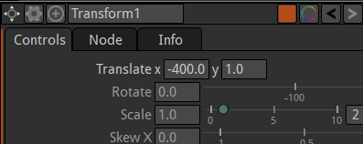
Now its position might be mirroring in the translate c and y properties of the transform property associated with the logo
as shown below

we will right click on the translate field and now in menu we click on Set Key (all dimenstion)

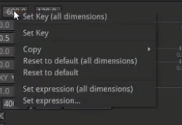
Now thw field bg color is set to blue color

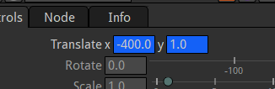
means the current frame is set as keyframe now we just go to middle frame in all 250 frames that is 125 frame
and now the field set is equal to light blue color as shown below

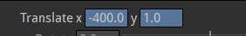
Now we dragging we plce the logo in teh center as shsoen below

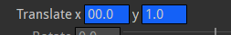

and the filed color is blue means keyframe is set in 125 frame Now you play the video it will be sliding
It might be slow when it is rendering as well as playing and may become more slower if more nodes are added while rendering and playing but when they reneder out then the video will be played smoothly means(set frame rate)

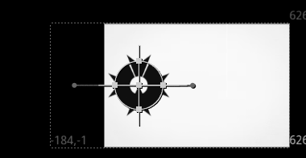
8:55
Now when the logo reach the center we want it to grow from the center and then make it look normal and then move it out of the screen
So now go to 125 frame and then in tranform properties set the keyframe for scale

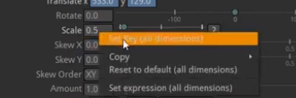
So here we set the keyframe for scale not for translate but if you move the icon image by drag and drop then we set the keyframe for trnslate there
If you want to keep the value same and dtill set the keyframe then you can set the keyframe there as shown above
by set keyframe (for all dimension)
SO our icon isl like that in frame 125 for now

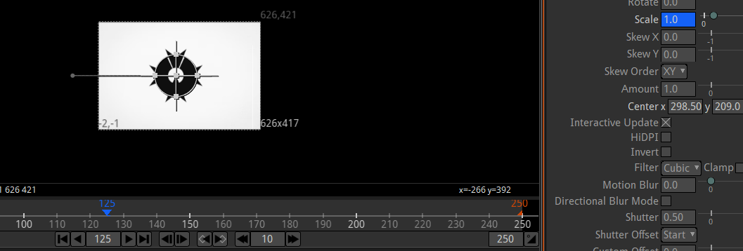

Now we set the scale here and hten after 10 frames that is 135 you scale the image by an d make it bigger as shown below

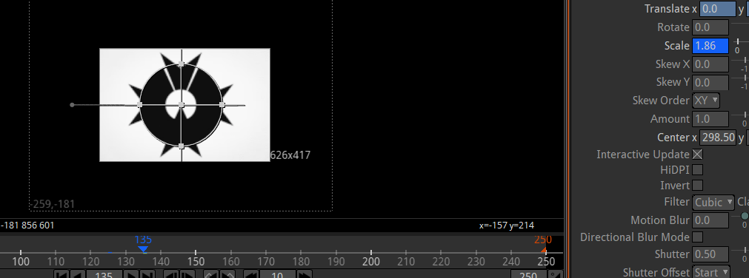
Now after 10 frames (that is 145 frames) we make it bck to normal as shown below

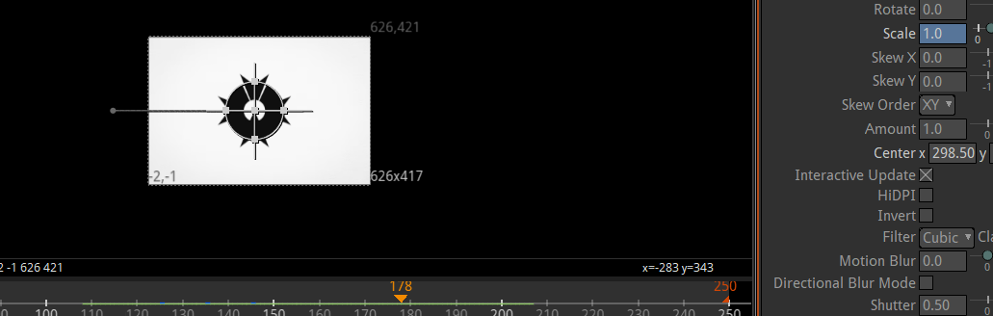
Now in 145 frame we continue our translate animation so we set the keyframe here
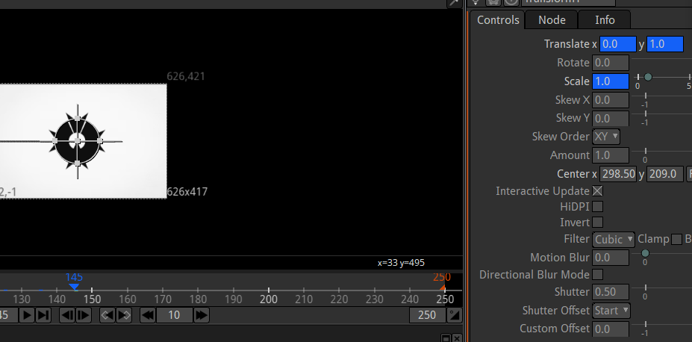

and then iun 250 frame we set the logo location to out of frame duw to which a keyframe will be set here
as shown below

We don't do the text aniumation here we will do it another lesson

A major mistake people do while animating is that not setting the keyframe
So make sure the field you are animating should have blue color not grey color
If it is light blue hten it s being effected by the keyframes in the project
Now we will render output Now to render it we need write node
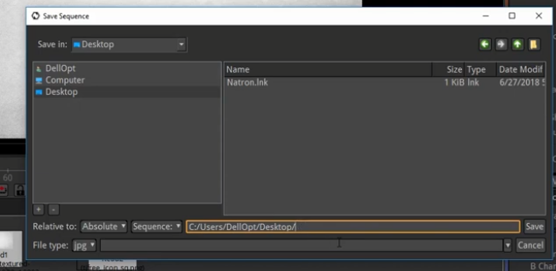
when you choose the sequence then images will be genreated for each frame and each image name has a structure like image name and then pound sign (#(if you use it in the field above)(maybe)) then followed by the number of rame it is representing(who knows)

So create a write node and after doing its configuration link it to the first node that is also connected to the viewer node as shwon below

So that whatever you are seeing in viewwer node will be seen in your output as well

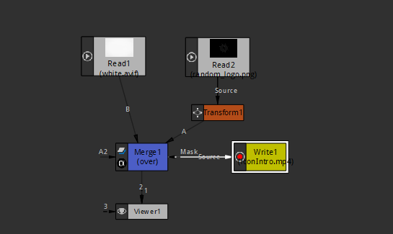
Always make sure that the frame rate in viewer and write properties is same otherwise output could be different in terms of speed (who knows)

15:10

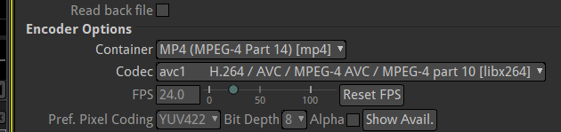
These are the codec we are using
Depending on your system if you are using Mac or linux Sometmes your codex if you facing problem when you are rendering it out you might need ot change he codec or container so instead of MP4 you use mov
So we are rendering the entire project
Now click on render button to render the output
now a video will be shown in the location which you have selected as marked below

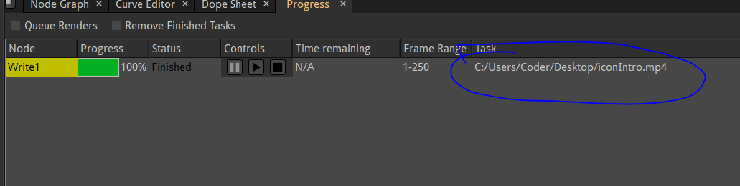
Now you can view your output

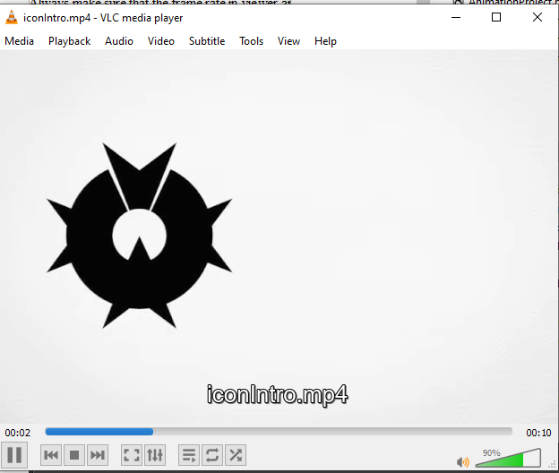

and now what you can do is throw this into a video editor and add some sound to it lik a little bouncy sound or something and now we have got a cool little intro video

